Sample Placement Form

Project Title:

Applicant:

Department and Division:

Significance:

Specific Goals of the Project:

Aim 1:

Aim 2:

Impact:

Project Impact, alignment with department and SoM priorities, career impact for junior faculty

Approach:
Data and Data Access Status:

Aim 1:

Aim 2:

Fellow Opportunities:

Please elaborate on how the clinical team will ensure the fellow understands the clinical question and how results can be applied. Also, please list any opportunities for dissemination or implementation or any unique opportunities the fellow will have access to.

Timeline:

Project Team:

Please include any staff already determined to be appropriate for the project or any TBD positions and adjust FTE and funding
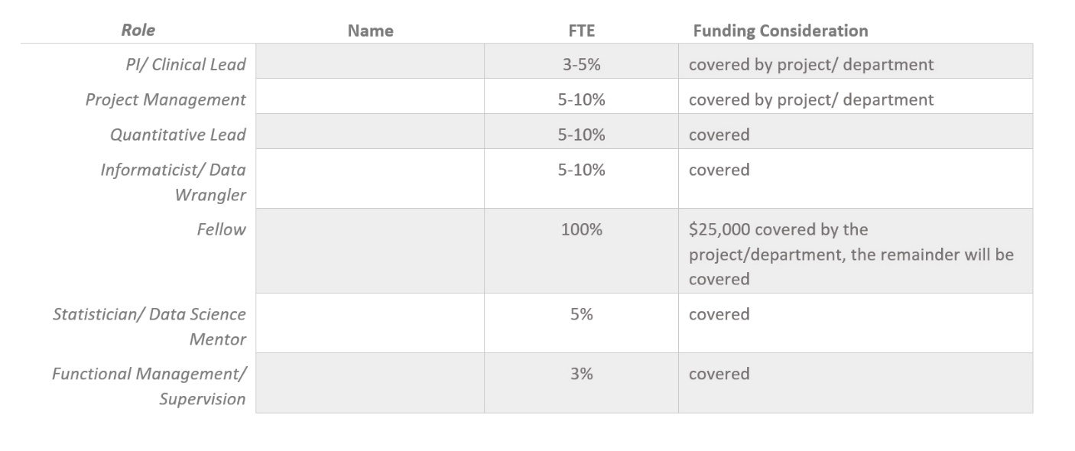

Additional budget beyond labor:

Additional Partnership:
DIHI, LHU, ACE

References:

