Pathology AI Health Fellow Placement Application Form

Project Title:

Applicant:

Significance:

Specific Goals of the Project:

Aim 1:

Aim 2:

Impact:

Project Impact, alignment with department priorities, career impact for junior faculty

Approach:
Data and Data Access Status:

Aim 1:

Aim 2:

Fellow Opportunities:

Please elaborate on how the clinical team will ensure the fellow understands the clinical question and how results can be applied. Also, please list any opportunities for dissemination or implementation or any unique opportunities the fellow will have access to.

Timeline:

Project Team:

The sample table below lists suggested team members, feel free to add or delete rows, and adjust effort as applicable to the project. Please include any staff already determined to be appropriate, or use TBD for positions to be filled. List funding sources for all members of the team. If known, identify funding opportunities to cover AI Health Fellow in Year 2.

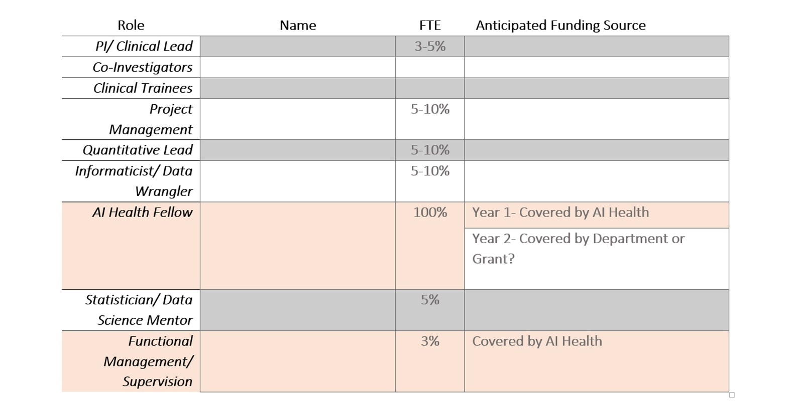

Additional budget beyond labor:

Additional Partnership:
DIHI, LHU, ACE

References:

